|  |  |  |  |  |
| --- | --- | --- | --- | --- |
|  |  |  | |  |
| Kitchen Story.COM  2023 | | |
| **simplilearn project for DevOps WAY** | | Ankitatribhuvan6@gmail.com |

|  |  |
| --- | --- |
|  | **developer detail**  Application: **KITCHEN STORY.COM**  Developer Details:  Name: Ankita Tribhuvan  Designation: Full Stack Java Developer  **Github LINK:** |

OVERVIEW

The project ‘THE TASTY KITCHEN’ is a restaurant website made using HTML and CSS for customers to get to know about the restaurant.

## GOALS

* Landing page for the restaurant.
* To provide the information about the restaurant.
* To provide the recipe menu list and services provided by the restaurant.
* Directing the website visitors to order the food in a food ordering website like zomato.
* Making the website visitors to follow the social media page of the restaurant.

## SPECIFICATIONS

* We added a logo and navigation bar items for easy use of the website.
* Added the picture with details of the recipes and the information services provided by the restaurant.
* People can use Contact Us form to give feedback or for any queries.

## TOOLS

★ HTML

★ CSS

★ VS code

★ Google Fonts

## FILE STRUCTURE

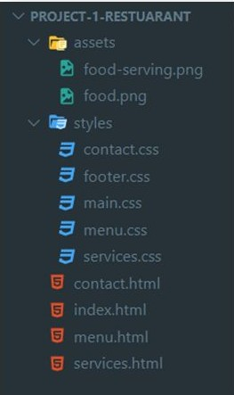

SOURCE CODE

[Full source code Github repository link: https://github.com/ shubhambhau/Kitchen-Story](https://github.com/darshanr27/restaurant-project)

### HTML

* index.html -

[https://github.com/shubhambhau/Kitchen-Story/blob/main/ index.html](https://github.com/darshanr27/restaurant-project/blob/master/index.html)

* menu.html -

[https://github.com/shubhambhau/Kitchen-Story/blob/main/ menu.html](https://github.com/darshanr27/restaurant-project/blob/master/menu.html)

* services.html -

[https://github.com/shubhambhau/Kitchen-Story/blob/main/ services.html](https://github.com/darshanr27/restaurant-project/blob/master/services.html)

* contact.html -

[https://github.com/shubhambhau/Kitchen-Story/blob/main/ contact.html](https://github.com/darshanr27/restaurant-project/blob/master/contact.html)

### CSS

* styles -

[https://github.com/shubhambhau/Kitchen-Story/tree/main/ styles](https://github.com/darshanr27/restaurant-project/tree/master/styles)

## OUTPUT

Note: Recommended the desktop view is best, not responsive to mobile screen.

### HOME

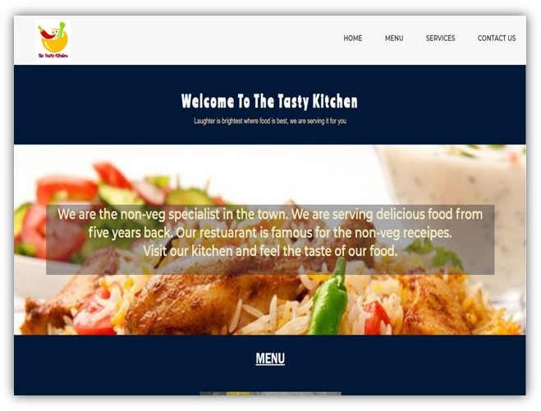

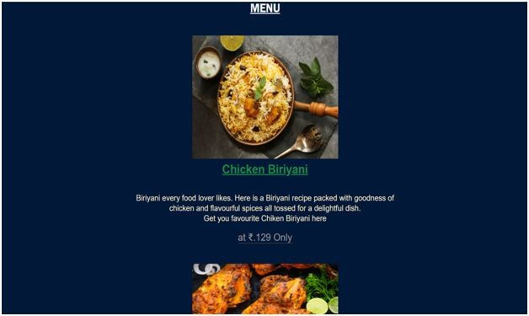

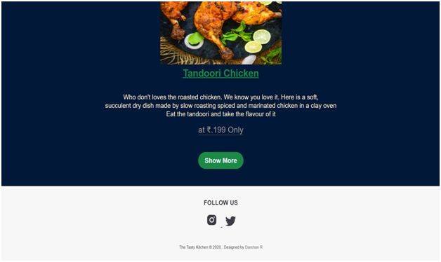

MENU

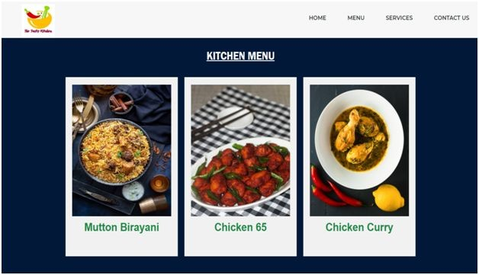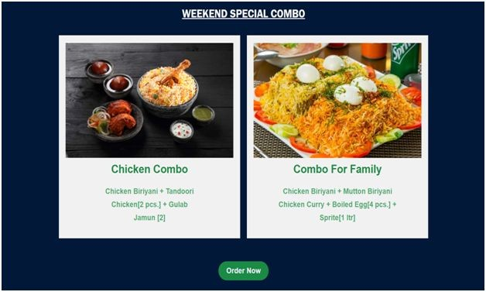

### SERVICES

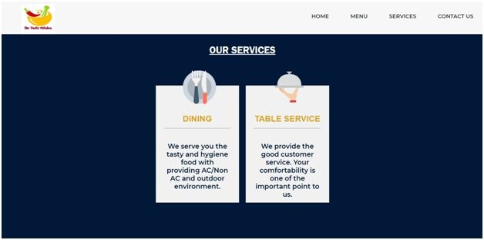

CONTACT US

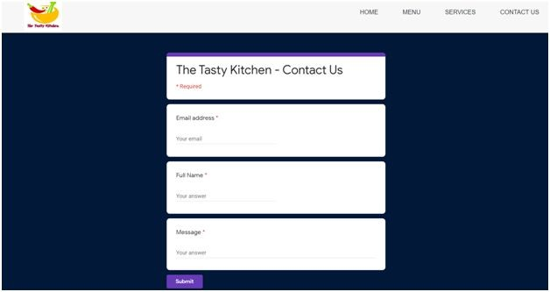

# THE END THANK YOU